--------------------------- DEBATE 1 ROUND 1--------------------------------

WARREN [('need', 13), ('make', 13), ('people', 11), ('great', 8), ('want', 8), ('fight', 8), ('giant', 7), ('us', 7), ('country', 7), ('healthcare', 7), ('economy', 6), ('one', 6), ('children', 6), ('work', 6), ('way', 5), ('families', 5), ('got', 5), ('government', 5), ('time', 5), ('means', 5)]

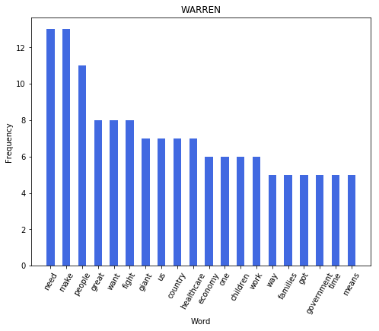

WARREN UNIQUE WORDS: 405

O ROURKE [('country', 14), ('would', 13), ('going', 11), ('make', 10), ('sure', 9), ('democracy', 7), ('able', 7), ('laws', 7), ('tax', 6), ('people', 6), ('texas', 6), ('care', 6), ('administration', 6), ('everyone', 5), ('us', 5), ('healthcare', 5), ('face', 5), ('one', 5), ('economy', 4), ('work', 4)]

O ROURKE UNIQUE WORDS : 569

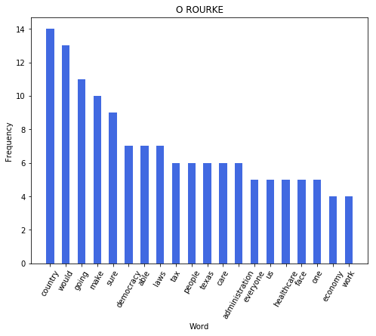

BOOKER [('people', 19), ('country', 11), ('need', 11), ('going', 11), ('problem', 10), ('one', 10), ('deal', 10), ('make', 9), ('senate', 8), ('like', 8), ('way', 8), ('get', 8), ('corporate', 7), ('americans', 7), ('go', 7), ('president', 7), ('see', 6), ('day', 6), ('first', 6), ('issue', 6)]

BOOKER UNIQUE WORDS : 522

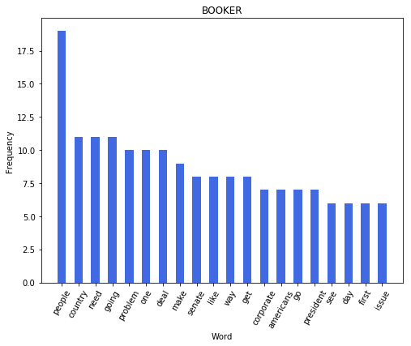

KLOBUCHAR [('would', 15), ('make', 12), ('going', 10), ('get', 10), ('think', 10), ('first', 8), ('people', 8), ('need', 8), ('everyone', 6), ('one', 6), ('sure', 6), ('president', 6), ('us', 6), ('well', 5), ('donald', 5), ('trump', 5), ('america', 5), ('go', 5), ('right', 5), ('back', 5)]

KLOBUCHAR UNIQUE WORDS : 431

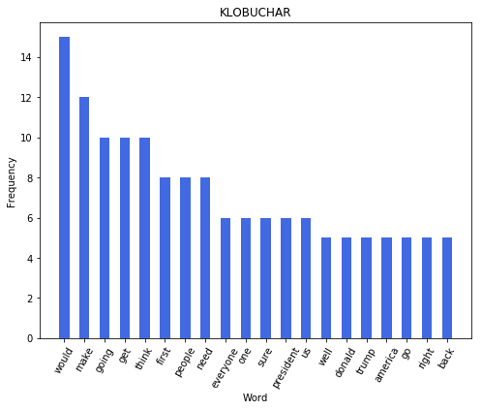

CASTRO [('would', 13), ('know', 12), ('section', 9), ('also', 7), ('like', 6), ('make', 6), ('one', 6), ('president', 6), ('first', 5), ('country', 5), ('right', 5), ('get', 5), ('policy', 5), ('asylum', 5), ('think', 5), ('across', 4), ('getting', 4), ('want', 4), ('sure', 4), ('everybody', 4)]

CASTRO UNIQUE WORDS : 432

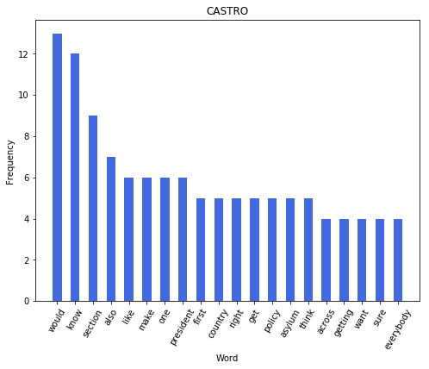

GABBARD [('war', 15), ('people', 11), ('us', 11), ('need', 9), ('american', 8), ('iran', 8), ('would', 8), ('president', 6), ('one', 6), ('every', 6), ('al', 5), ('money', 5), ('home', 5), ('afghanistan', 5), ('served', 4), ('new', 4), ('lives', 4), ('needs', 4), ('healthcare', 4), ('much', 4)]

GABBARD UNIQUE WORDS : 337

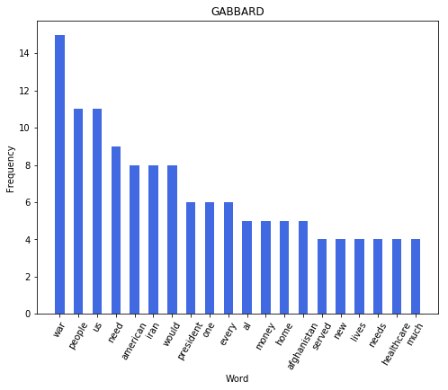

DE BLASIO [('people', 17), ('working', 14), ('party', 10), ('war', 7), ('every', 6), ('country', 6), ('money', 5), ('look', 5), ('american', 5), ('need', 5), ('matters', 5), ('new', 4), ('york', 4), ('city', 4), ('let', 4), ('first', 4), ('want', 4), ('supposed', 4), ('different', 4), ('put', 4)]

DE BLASIO UNIQUE WORDS : 315

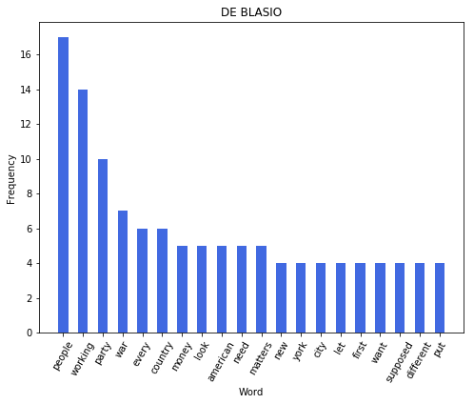

DELANEY [('country', 12), ('people', 11), ('american', 10), ('healthcare', 9), ('think', 8), ('need', 8), ('going', 8), ('president', 8), ('issue', 7), ('actually', 7), ('every', 7), ('one', 7), ('things', 6), ('right', 6), ('know', 6), ('jobs', 6), ('care', 6), ('law', 5), ('real', 4), ('us', 4)]

DELANEY UNIQUE WORDS : 336

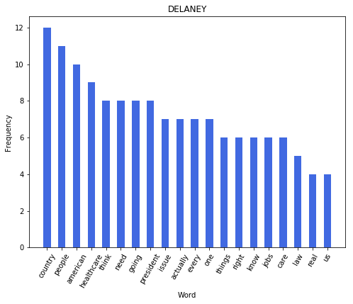

RYAN [('got', 11), ('president', 8), ('people', 8), ('need', 8), ('kids', 8), ('us', 8), ('want', 7), ('years', 6), ('going', 6), ('school', 6), ('saying', 6), ('engaged', 6), ('united', 5), ('states', 5), ('talking', 5), ('go', 5), ('get', 5), ('talk', 5), ('say', 4), ('think', 4)]

RYAN UNIQUE WORDS : 334

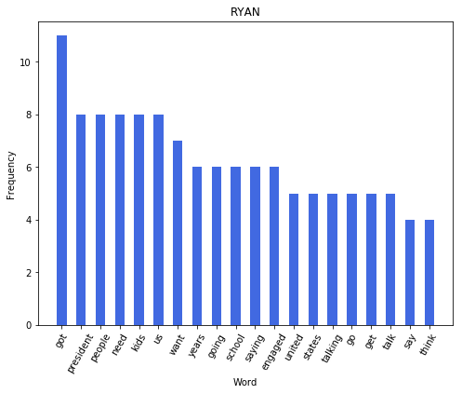

INSLEE [('people', 8), ('state', 6), ('candidate', 6), ('passed', 6), ('going', 5), ('law', 5), ('one', 5), ('first', 5), ('america', 4), ('proud', 4), ('put', 4), ('work', 4), ('president', 4), ('future', 4), ('look', 4), ('donald', 4), ('trump', 4), ('know', 4), ('united', 4), ('states', 4)]

INSLEE UNIQUE WORDS : 239

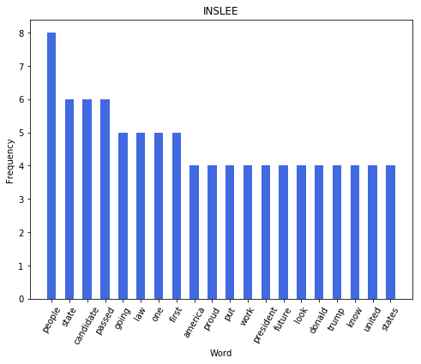

-----------------------------DEBATE 1 ROUND 2--------------------------------

SANDERS [('people', 20), ('country', 14), ('right', 11), ('health', 11), ('care', 11), ('believe', 9), ('let', 9), ('take', 8), ('america', 7), ('got', 7), ('insurance', 7), ('come', 7), ('medicare', 6), ('us', 6), ('trump', 6), ('companies', 6), ('one', 6), ('war', 6), ('well', 5), ('today', 5)]

SANDERS UNIQUE WORDS : 444

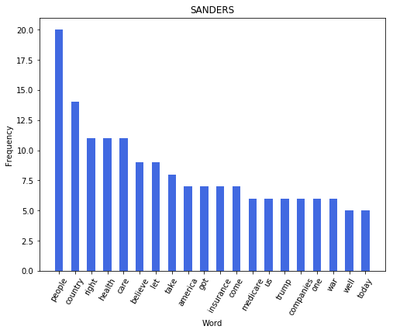

GILLIBRAND [('women', 11), ('president', 10), ('trump', 8), ('want', 7), ('get', 7), ('would', 7), ('one', 6), ('money', 6), ('corruption', 6), ('rights', 6), ('right', 5), ('care', 5), ('bill', 5), ('plan', 5), ('medicare', 5), ('heard', 5), ('politics', 5), ('take', 5), ('elections', 5), ('party', 4)]

GILLIBRAND UNIQUE WORDS : 362

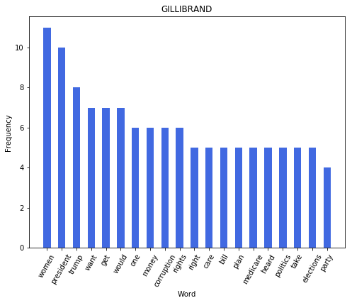

BENNET [('need', 11), ('people', 9), ('believe', 9), ('president', 8), ('united', 7), ('like', 6), ('got', 6), ('get', 6), ('think', 6), ('states', 6), ('washington', 6), ('deal', 6), ('thank', 5), ('well', 5), ('country', 5), ('years', 5), ('american', 5), ('medicare', 5), ('health', 5), ('right', 5)]

BENNET UNIQUE WORDS : 366

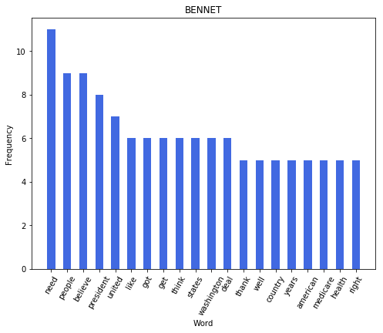

BIDEN [('would', 17), ('fact', 17), ('make', 14), ('sure', 13), ('people', 12), ('thing', 12), ('look', 11), ('able', 11), ('got', 11), ('go', 11), ('number', 11), ('president', 11), ('think', 10), ('one', 9), ('deal', 9), ('america', 7), ('insurance', 7), ('get', 7), ('ca', 7), ('way', 7)]

BIDEN UNIQUE WORDS : 580

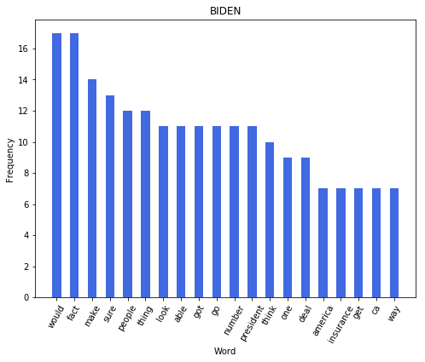

HARRIS [('people', 13), ('america', 12), ('president', 12), ('states', 12), ('issue', 10), ('united', 10), ('well', 8), ('tell', 8), ('country', 8), ('one', 8), ('us', 8), ('working', 7), ('need', 7), ('want', 7), ('great', 7), ('economy', 6), ('know', 6), ('going', 6), ('say', 6), ('take', 6)]

HARRIS UNIQUE WORDS : 504

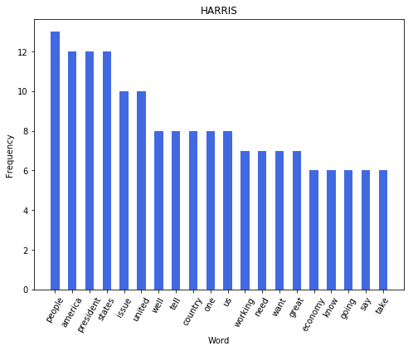

HICKENLOOPER [('first', 8), ('think', 7), ('would', 7), ('health', 6), ('got', 6), ('care', 5), ('together', 5), ('big', 5), ('country', 5), ('make', 5), ('years', 5), ('well', 4), ('us', 4), ('every', 4), ('universal', 4), ('people', 4), ('colorado', 4), ('america', 4), ('methane', 4), ('done', 4)]

HICKENLOOPER UNIQUE WORDS : 281

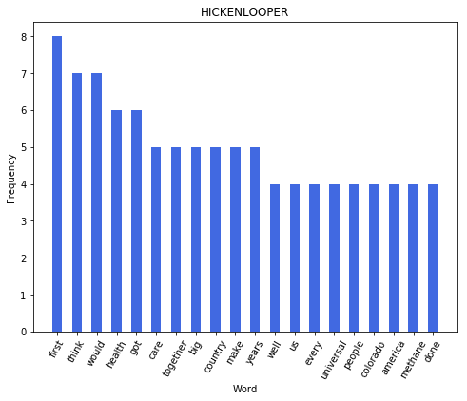

BUTTIGIEG [('people', 13), ('country', 9), ('right', 9), ('us', 8), ('want', 8), ('would', 8), ('got', 8), ('every', 7), ('get', 7), ('look', 7), ('american', 7), ('around', 7), ('college', 6), ('could', 6), ('even', 6), ('like', 6), ('thing', 6), ('going', 6), ('community', 6), ('part', 6)]

BUTTIGIEG UNIQUE WORDS : 560

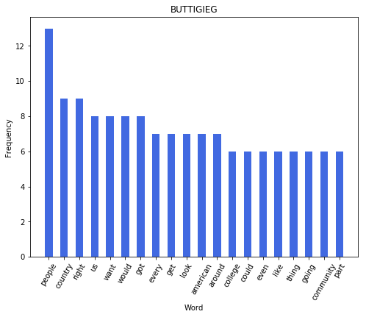

YANG [('would', 10), ('jobs', 8), ('trump', 6), ('donald', 5), ('right', 4), ('american', 4), ('people', 4), ('economy', 4), ('money', 4), ('china', 4), ('need', 3), ('tax', 3), ('millions', 3), ('healthier', 3), ('well', 3), ('trade', 3), ('climate', 3), ('change', 3), ('beat', 3), ('got', 2)]

YANG UNIQUE WORDS : 224

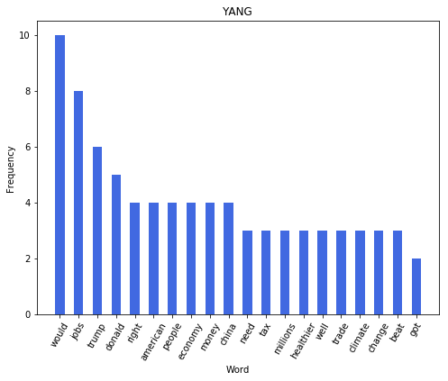

SWALWELL [('generation', 15), ('going', 8), ('pass', 8), ('torch', 8), ('solve', 6), ('ca', 5), ('people', 5), ('student', 5), ('debt', 5), ('america', 5), ('one', 5), ('gun', 5), ('buy', 4), ('loan', 4), ('seen', 4), ('violence', 4), ('single', 4), ('years', 3), ('million', 3), ('family', 3)]

SWALWELL UNIQUE WORDS : 270

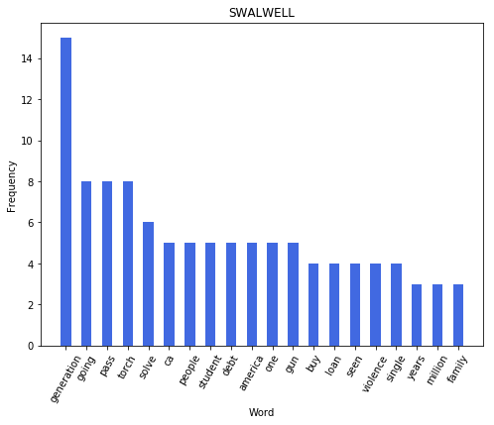

WILLIAMSON [('going', 17), ('trump', 6), ('important', 6), ('say', 5), ('plans', 5), ('donald', 5), ('united', 5), ('states', 5), ('policies', 5), ('child', 5), ('john', 5), ('kennedy', 5), ('man', 5), ('america', 4), ('great', 4), ('health', 4), ('system', 4), ('somebody', 4), ('talk', 4), ('children', 4)]

WILLIAMSON UNIQUE WORDS : 257

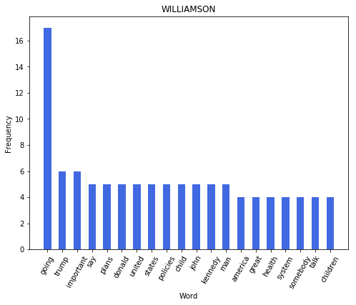

--------------------------------DEBATE 2 ROUND 1-----------------------------

SANDERS [('people', 19), ('going', 17), ('got', 12), ('america', 11), ('health', 10), ('industry', 10), ('right', 9), ('companies', 9), ('american', 9), ('system', 9), ('insurance', 9), ('care', 8), ('percent', 8), ('new', 8), ('want', 8), ('country', 8), ('one', 7), ('take', 7), ('trump', 7), ('medicare', 7)]

SANDERS UNIQUE WORDS : 611

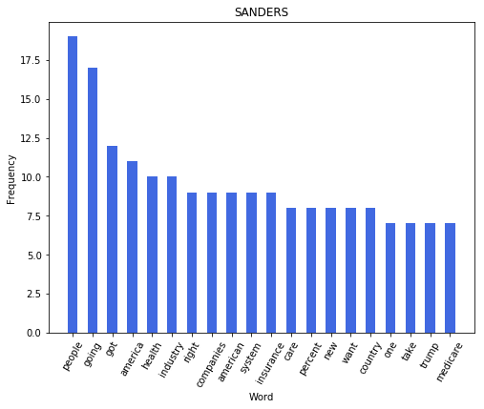

WARREN [('people', 19), ('going', 16), ('right', 16), ('need', 14), ('world', 14), ('health', 13), ('insurance', 13), ('donald', 12), ('trump', 12), ('know', 12), ('fight', 12), ('get', 12), ('every', 11), ('country', 10), ('care', 10), ('say', 10), ('companies', 9), ('beat', 8), ('make', 8), ('want', 8)]

WARREN UNIQUE WORDS : 566

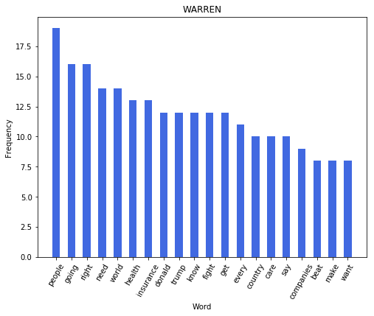

BUTTIGIEG [('president', 13), ('like', 10), ('right', 10), ('going', 10), ('know', 9), ('country', 8), ('people', 8), ('think', 8), ('whether', 7), ('want', 7), ('community', 7), ('would', 7), ('years', 6), ('away', 6), ('get', 6), ('school', 6), ('need', 6), ('actually', 6), ('time', 5), ('crisis', 5)]

BUTTIGIEG UNIQUE WORDS : 659

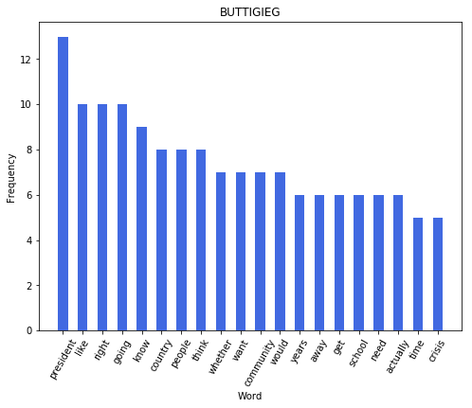

O ROURKE [('country', 22), ('people', 15), ('everyone', 14), ('care', 10), ('want', 9), ('also', 8), ('every', 7), ('texas', 7), ('president', 6), ('america', 6), ('us', 6), ('first', 6), ('one', 6), ('american', 6), ('health', 6), ('make', 5), ('medicare', 5), ('college', 5), ('challenge', 5), ('bring', 5)]

O ROURKE UNIQUE WORDS : 556

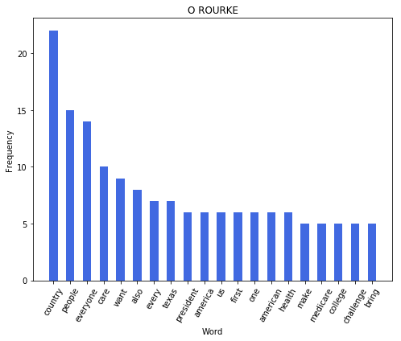

KLOBUCHAR [('people', 17), ('president', 11), ('would', 11), ('get', 9), ('think', 9), ('need', 8), ('first', 7), ('make', 7), ('better', 7), ('everyone', 7), ('say', 7), ('like', 7), ('going', 6), ('yes', 6), ('bill', 6), ('little', 5), ('country', 5), ('win', 5), ('said', 5), ('done', 5)]

KLOBUCHAR UNIQUE WORDS : 452

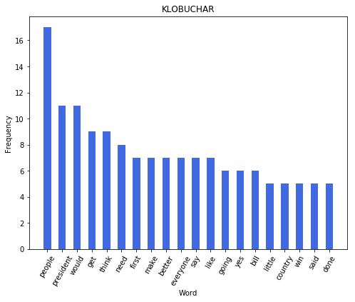

HICKENLOOPER [('got', 17), ('going', 14), ('country', 11), ('people', 10), ('years', 8), ('make', 8), ('know', 8), ('think', 8), ('get', 7), ('trump', 6), ('well', 6), ('every', 6), ('one', 5), ('work', 5), ('done', 5), ('donald', 5), ('back', 5), ('world', 5), ('trade', 5), ('small', 4)]

HICKENLOOPER UNIQUE WORDS : 447

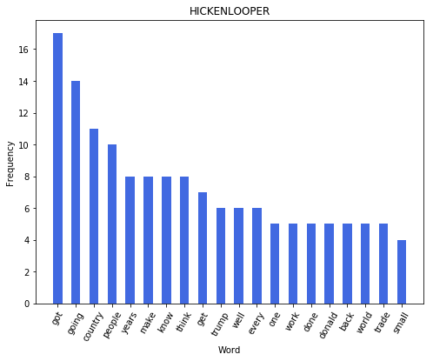

RYAN [('going', 15), ('better', 12), ('new', 12), ('make', 12), ('think', 11), ('healthcare', 10), ('system', 9), ('get', 9), ('united', 9), ('china', 9), ('people', 8), ('got', 8), ('percent', 8), ('left', 7), ('union', 7), ('plan', 7), ('thing', 7), ('states', 7), ('country', 7), ('us', 6)]

RYAN UNIQUE WORDS : 440

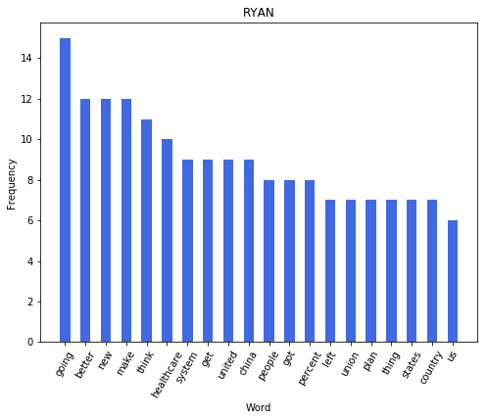

DELANEY [('health', 18), ('care', 15), ('think', 12), ('right', 11), ('president', 11), ('wealthy', 9), ('medicare', 8), ('private', 8), ('would', 8), ('people', 8), ('tax', 8), ('senator', 7), ('universal', 7), ('real', 7), ('going', 7), ('go', 6), ('impossible', 6), ('get', 6), ('create', 6), ('american', 6)]

DELANEY UNIQUE WORDS : 449

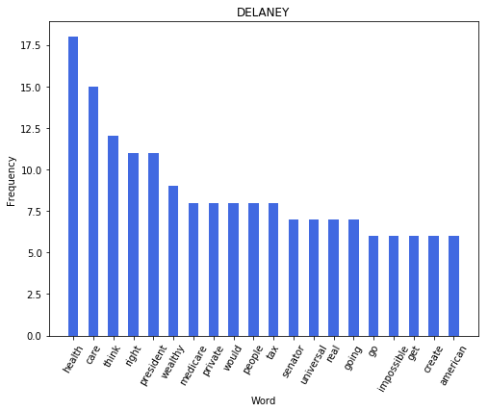

WILLIAMSON [('people', 19), ('need', 13), ('billion', 9), ('say', 8), ('us', 8), ('policies', 7), ('trump', 7), ('would', 6), ('think', 6), ('time', 5), ('politics', 5), ('concern', 5), ('talking', 5), ('fight', 5), ('party', 5), ('talk', 5), ('going', 5), ('flint', 5), ('country', 5), ('donald', 5)]

WILLIAMSON UNIQUE WORDS : 405

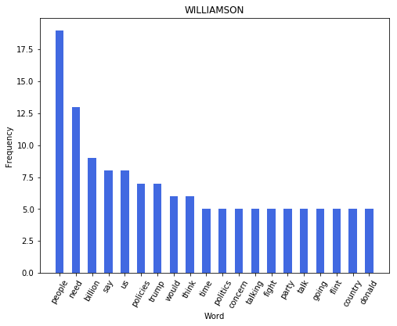

BULLOCK [('going', 15), ('actually', 13), ('people', 10), ('know', 10), ('get', 10), ('trump', 9), ('america', 9), ('look', 8), ('way', 8), ('think', 8), ('folks', 7), ('win', 7), ('like', 7), ('president', 7), ('make', 7), ('want', 7), ('would', 7), ('donald', 6), ('back', 6), ('health', 6)]

BULLOCK UNIQUE WORDS : 439

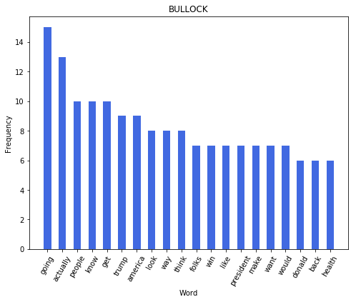

------------------------------DEBATE 2 ROUND 2-------------------------------

BIDEN [('fact', 39), ('plan', 27), ('president', 22), ('people', 22), ('would', 22), ('get', 18), ('one', 18), ('number', 17), ('sure', 14), ('know', 13), ('years', 12), ('make', 12), ('country', 11), ('matter', 11), ('able', 11), ('time', 10), ('insurance', 10), ('said', 10), ('think', 9), ('senator', 9)]

BIDEN UNIQUE WORDS : 750

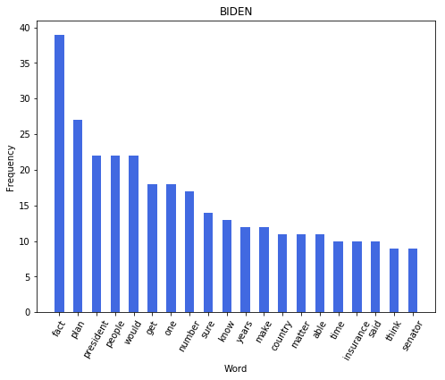

HARRIS [('plan', 30), ('people', 24), ('president', 19), ('united', 18), ('states', 18), ('going', 15), ('work', 15), ('american', 14), ('would', 14), ('justice', 13), ('families', 11), ('america', 11), ('medicare', 10), ('women', 10), ('care', 9), ('one', 9), ('healthcare', 9), ('position', 9), ('think', 8), ('time', 8)]

HARRIS UNIQUE WORDS : 641

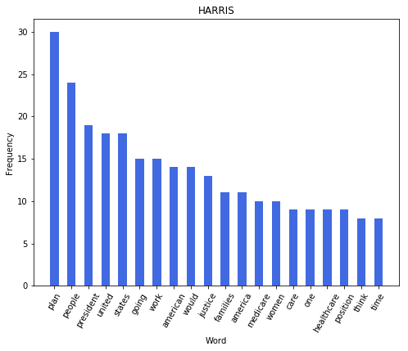

BOOKER [('president', 15), ('us', 12), ('going', 12), ('donald', 11), ('trump', 11), ('people', 11), ('like', 11), ('right', 10), ('one', 10), ('united', 9), ('states', 9), ('country', 9), ('want', 9), ('city', 8), ('common', 8), ('well', 8), ('first', 8), ('say', 8), ('vice', 8), ('need', 7)]

BOOKER UNIQUE WORDS : 572

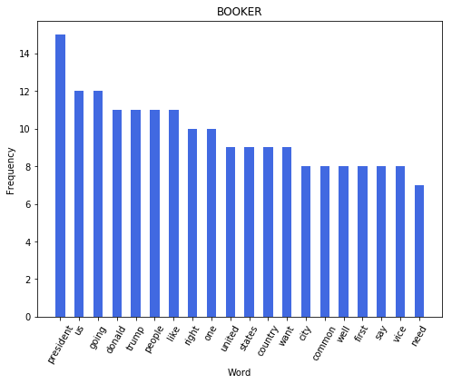

CASTRO [('going', 15), ('know', 13), ('president', 10), ('folks', 10), ('need', 9), ('well', 9), ('believe', 8), ('go', 7), ('let', 7), ('say', 7), ('justice', 7), ('want', 6), ('like', 6), ('nation', 6), ('people', 6), ('plan', 6), ('thank', 5), ('good', 5), ('americans', 5), ('us', 5)]

CASTRO UNIQUE WORDS : 456

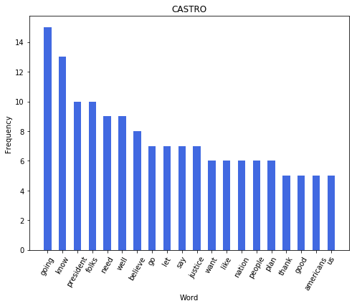

YANG [('right', 12), ('american', 11), ('would', 11), ('people', 11), ('know', 8), ('need', 8), ('every', 7), ('like', 7), ('jobs', 7), ('much', 7), ('trump', 7), ('well', 7), ('going', 7), ('start', 7), ('president', 6), ('month', 6), ('donald', 6), ('us', 6), ('way', 6), ('years', 6)]

YANG UNIQUE WORDS : 478

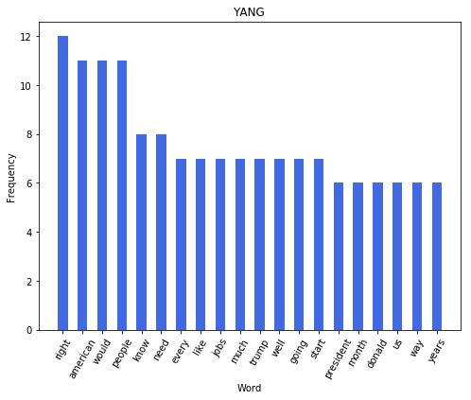

GABBARD [('people', 24), ('country', 17), ('would', 10), ('system', 9), ('us', 9), ('president', 8), ('bring', 7), ('right', 6), ('war', 6), ('deployed', 5), ('trump', 5), ('like', 5), ('american', 5), ('make', 5), ('way', 5), ('many', 4), ('serving', 4), ('every', 4), ('single', 4), ('sick', 4)]

GABBARD UNIQUE WORDS : 526

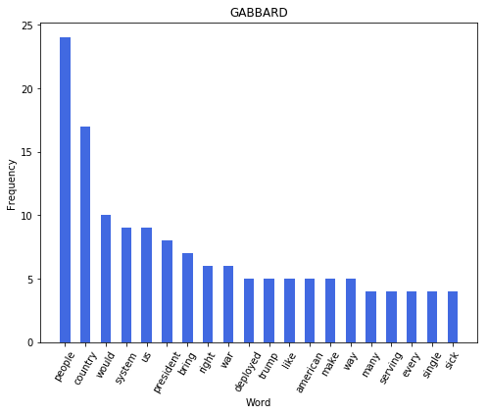

GILLIBRAND [('president', 15), ('women', 13), ('people', 11), ('trump', 9), ('know', 9), ('want', 8), ('need', 8), ('said', 8), ('done', 7), ('care', 7), ('going', 7), ('make', 7), ('family', 7), ('home', 7), ('impossible', 6), ('health', 6), ('think', 6), ('america', 6), ('would', 6), ('working', 6)]

GILLIBRAND UNIQUE WORDS : 494

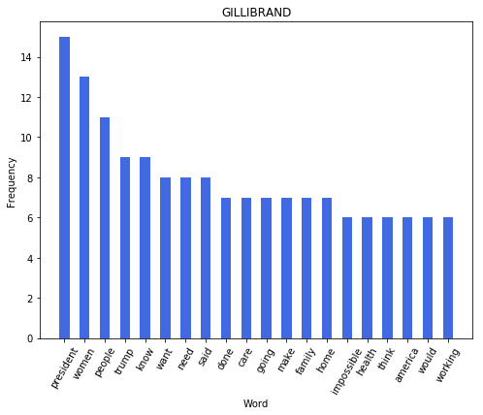

INSLEE [('need', 10), ('proud', 10), ('president', 9), ('believe', 9), ('plan', 8), ('one', 8), ('get', 8), ('state', 8), ('think', 7), ('going', 7), ('united', 6), ('states', 6), ('know', 6), ('people', 5), ('democrats', 5), ('make', 5), ('climate', 5), ('done', 5), ('first', 5), ('like', 5)]

INSLEE UNIQUE WORDS : 406

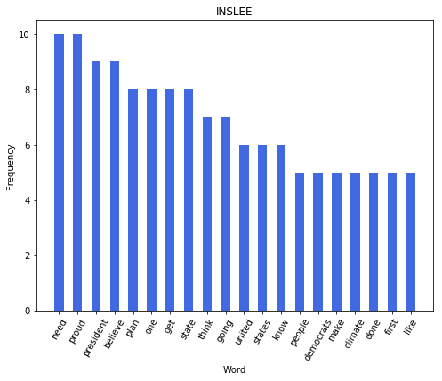

BENNET [('country', 12), ('people', 11), ('trump', 10), ('make', 10), ('need', 9), ('president', 8), ('donald', 8), ('kids', 7), ('years', 7), ('public', 7), ('trillion', 7), ('going', 7), ('last', 6), ('america', 6), ('believe', 6), ('insurance', 6), ('taxes', 6), ('us', 6), ('parents', 5), ('option', 5)]

BENNET UNIQUE WORDS : 426

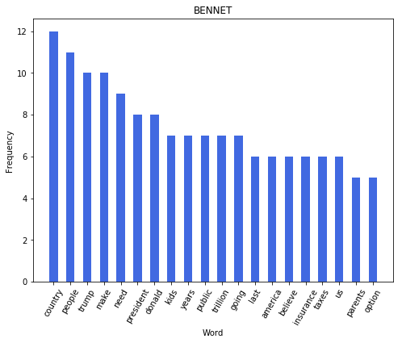

DE BLASIO [('people', 24), ('president', 16), ('going', 16), ('working', 11), ('insurance', 11), ('vice', 10), ('health', 10), ('party', 10), ('say', 9), ('something', 9), ('make', 8), ('country', 8), ('get', 8), ('american', 8), ('donald', 8), ('trump', 8), ('know', 7), ('done', 7), ('right', 7), ('justice', 7)]

DE BLASIO UNIQUE WORDS : 412

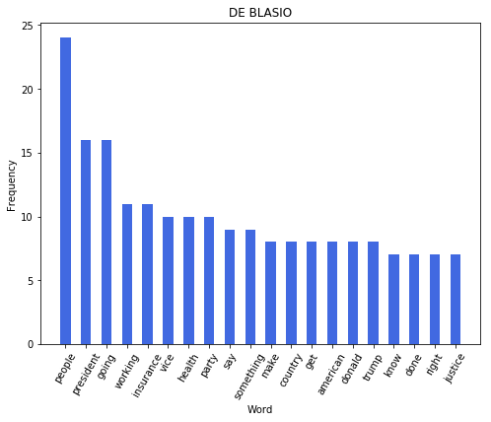

-----------------------------------Debate 3----------------------------------

BIDEN [('get', 20), ('said', 19), ('going', 18), ('people', 16), ('president', 14), ('way', 14), ('number', 14), ('one', 13), ('fact', 13), ('things', 13), ('like', 12), ('sure', 12), ('know', 11), ('go', 11), ('got', 11), ('make', 11), ('look', 10), ('think', 10), ('let', 9), ('deal', 9)]

BIDEN UNIQUE WORDS : 675

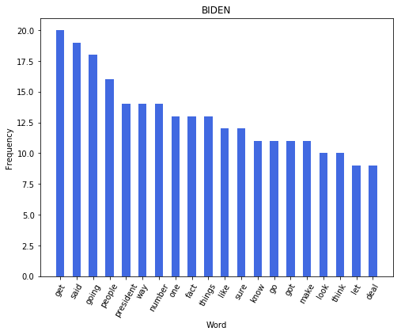

WARREN [('going', 18), ('got', 15), ('people', 15), ('country', 14), ('every', 14), ('want', 13), ('need', 12), ('health', 11), ('care', 11), ('back', 10), ('school', 9), ('america', 9), ('get', 9), ('let', 9), ('time', 9), ('pay', 8), ('teacher', 8), ('us', 8), ('families', 8), ('insurance', 8)]

WARREN UNIQUE WORDS : 539

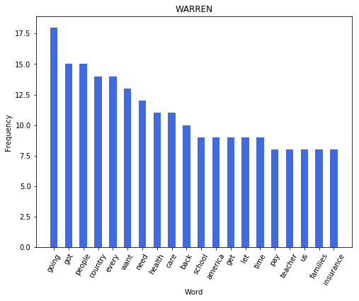

BOOKER [('people', 23), ('america', 12), ('right', 12), ('us', 10), ('president', 10), ('community', 9), ('common', 9), ('system', 9), ('know', 9), ('want', 9), ('issue', 9), ('justice', 9), ('going', 8), ('make', 8), ('stage', 8), ('nation', 8), ('go', 8), ('one', 8), ('criminal', 8), ('like', 8)]

BOOKER UNIQUE WORDS : 676

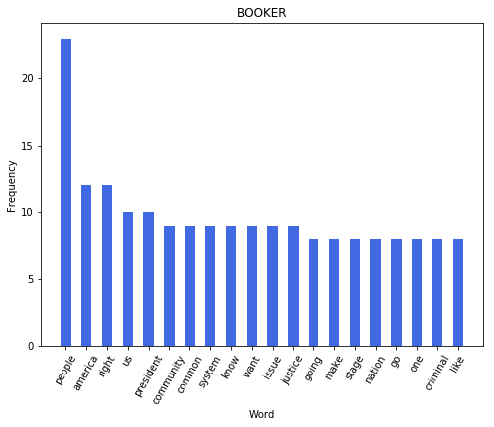

SANDERS [('country', 18), ('people', 15), ('health', 13), ('care', 13), ('got', 10), ('insurance', 9), ('every', 8), ('medicare', 8), ('year', 8), ('companies', 7), ('want', 7), ('president', 6), ('right', 6), ('going', 6), ('trade', 6), ('let', 5), ('goes', 5), ('trump', 5), ('make', 5), ('system', 5)]

SANDERS UNIQUE WORDS : 491

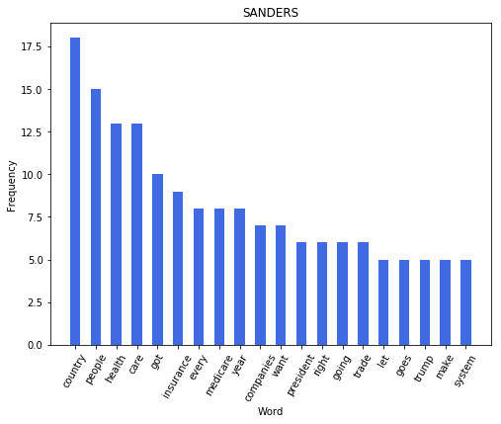

HARRIS [('people', 13), ('need', 12), ('first', 10), ('trump', 10), ('know', 10), ('tell', 10), ('plan', 9), ('get', 9), ('issue', 9), ('donald', 8), ('one', 8), ('look', 8), ('us', 7), ('done', 7), ('justice', 7), ('would', 7), ('care', 7), ('say', 7), ('going', 7), ('system', 7)]

HARRIS UNIQUE WORDS : 531

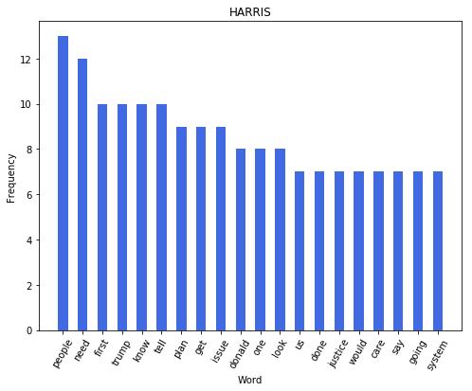

BUTTIGIEG [('know', 12), ('people', 11), ('president', 11), ('us', 10), ('way', 10), ('one', 10), ('american', 7), ('get', 7), ('would', 6), ('right', 6), ('plan', 6), ('like', 6), ('got', 6), ('actually', 6), ('around', 6), ('part', 5), ('came', 5), ('trust', 5), ('immigration', 5), ('need', 4)]

BUTTIGIEG UNIQUE WORDS : 540

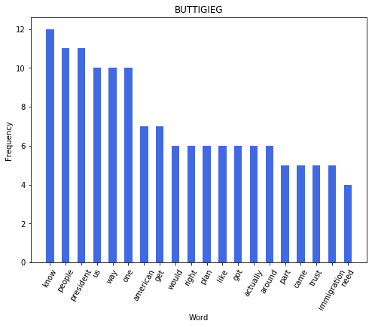

CASTRO [('would', 17), ('president', 14), ('know', 12), ('plan', 12), ('said', 11), ('going', 11), ('look', 10), ('need', 10), ('schools', 10), ('also', 9), ('believe', 9), ('like', 9), ('obama', 8), ('people', 8), ('ago', 8), ('job', 7), ('thank', 6), ('barack', 6), ('family', 6), ('wanted', 6)]

CASTRO UNIQUE WORDS : 473

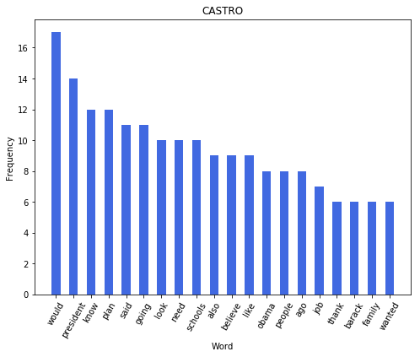

KLOBUCHAR [('us', 15), ('think', 12), ('people', 12), ('get', 11), ('got', 10), ('going', 10), ('want', 10), ('country', 8), ('one', 8), ('bring', 7), ('day', 7), ('like', 6), ('would', 6), ('make', 6), ('way', 6), ('said', 6), ('right', 6), ('done', 6), ('unites', 5), ('someone', 5)]

KLOBUCHAR UNIQUE WORDS : 479

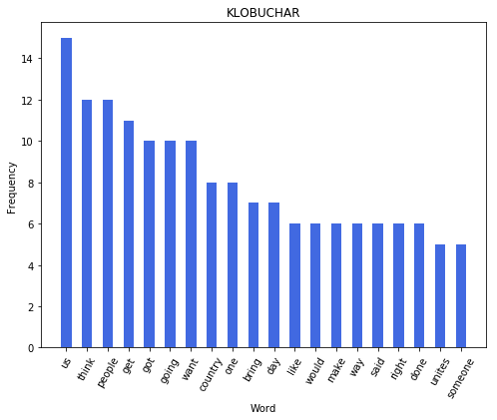

O ROURKE [('country', 11), ('america', 10), ('texas', 9), ('people', 8), ('right', 7), ('going', 7), ('think', 6), ('able', 6), ('make', 6), ('fact', 6), ('el', 5), ('paso', 5), ('system', 5), ('times', 5), ('get', 5), ('part', 4), ('weapon', 4), ('president', 4), ('one', 4), ('see', 4)]

O ROURKE UNIQUE WORDS : 490

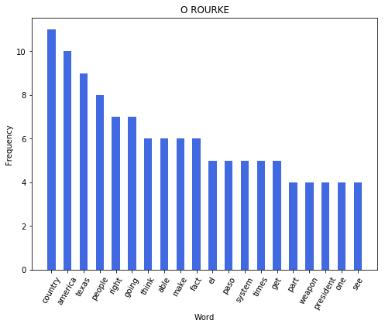

YANG [('american', 13), ('people', 12), ('money', 10), ('know', 10), ('president', 9), ('way', 7), ('would', 7), ('one', 7), ('health', 6), ('want', 6), ('country', 5), ('us', 5), ('give', 5), ('come', 5), ('companies', 5), ('time', 4), ('going', 4), ('right', 4), ('tell', 4), ('everyone', 4)]

YANG UNIQUE WORDS : 443

